- Take snapshot of your DB before working on this utility.
- Run below SP’s in the working DB
  - Utility_DataFix_Log_Table_Scripts.sql
  - InsertMissingSubAgentCommSuspenseTD.sql
  - spu_allocate_transdetail_ids.sql
  - spu_CorrectComissionPosting.sql
  - spu_InsertMissingComissionReleaseToAgent.sql
  - spu_GetMissingComissionReleaseToAgent.sql
- Copy the files from iPMUDataFixUtility_CAIC_PM058633.zip to C:\Pure\Application (Pure Application root folder).
Part 1 Fix
- Copy the query in file ‘Find INC - IRC with missing COLLACC.sql’ and paste the same in Tab 1 i.e. (Sub-Agent Suspense Posting Fix).
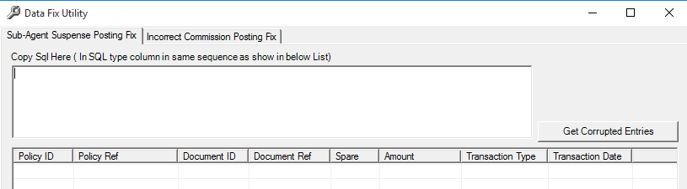
- Run the iPMUDataFixUtility_CAIC_PM058633.exe, paste the query from above steps and click on ‘Get Corrupted Entries’ to get all the records.
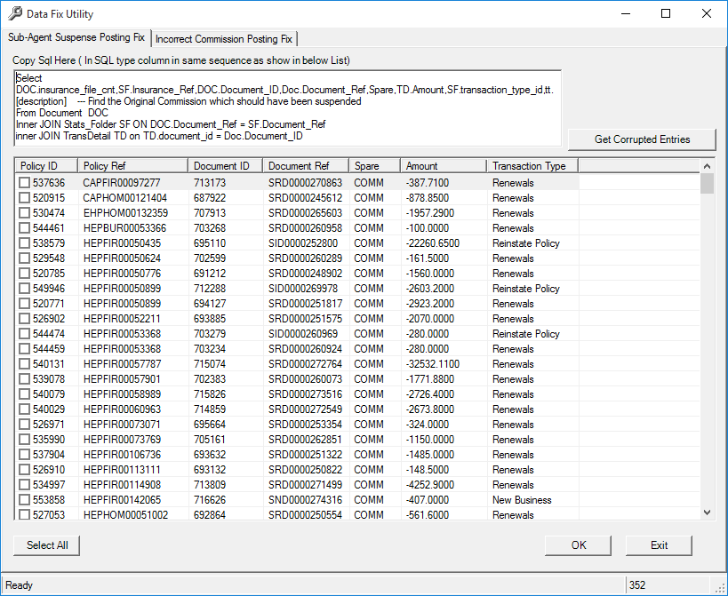
- Select 1 or multiple rows to run the fix. Once selected click on OK to fix the records. Once completed success message will be displayed
Part 2 Fix
- Copy the query in file ‘Find Incorrect Commission Posting Records.sql’ and paste the same in Tab 2 i.e. (Sub-Agent Suspense Posting Fix).
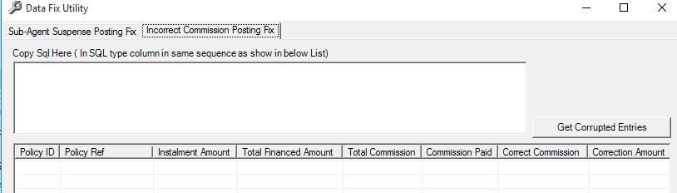
- Paste the query from above steps and click on ‘Get Corrupted Entries’ to get all the records.
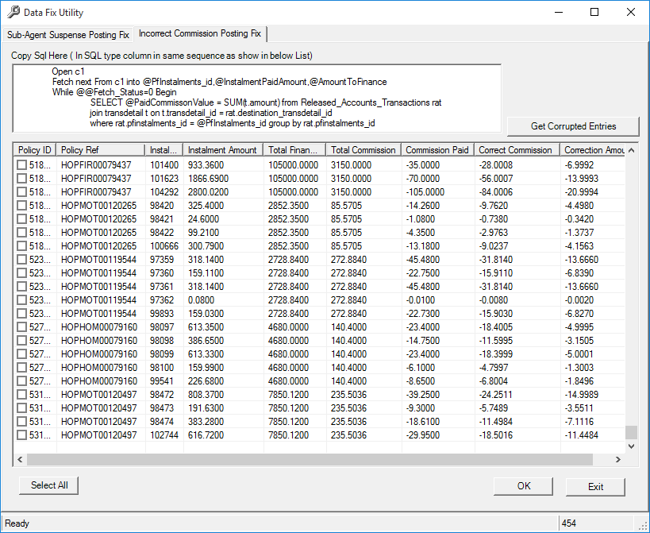
- Select 1 or multiple rows to run the fix. Once selected click on OK to fix the records. Once completed success message will be displayed.

